INTERSTATE BRIDGE REPLACEMENT PROGRAM
PROGRAMMATIC AGREEMENT

Attachment B: Area of Potential Effects

Figure B-1. Area of Potential Effects (October 2025)
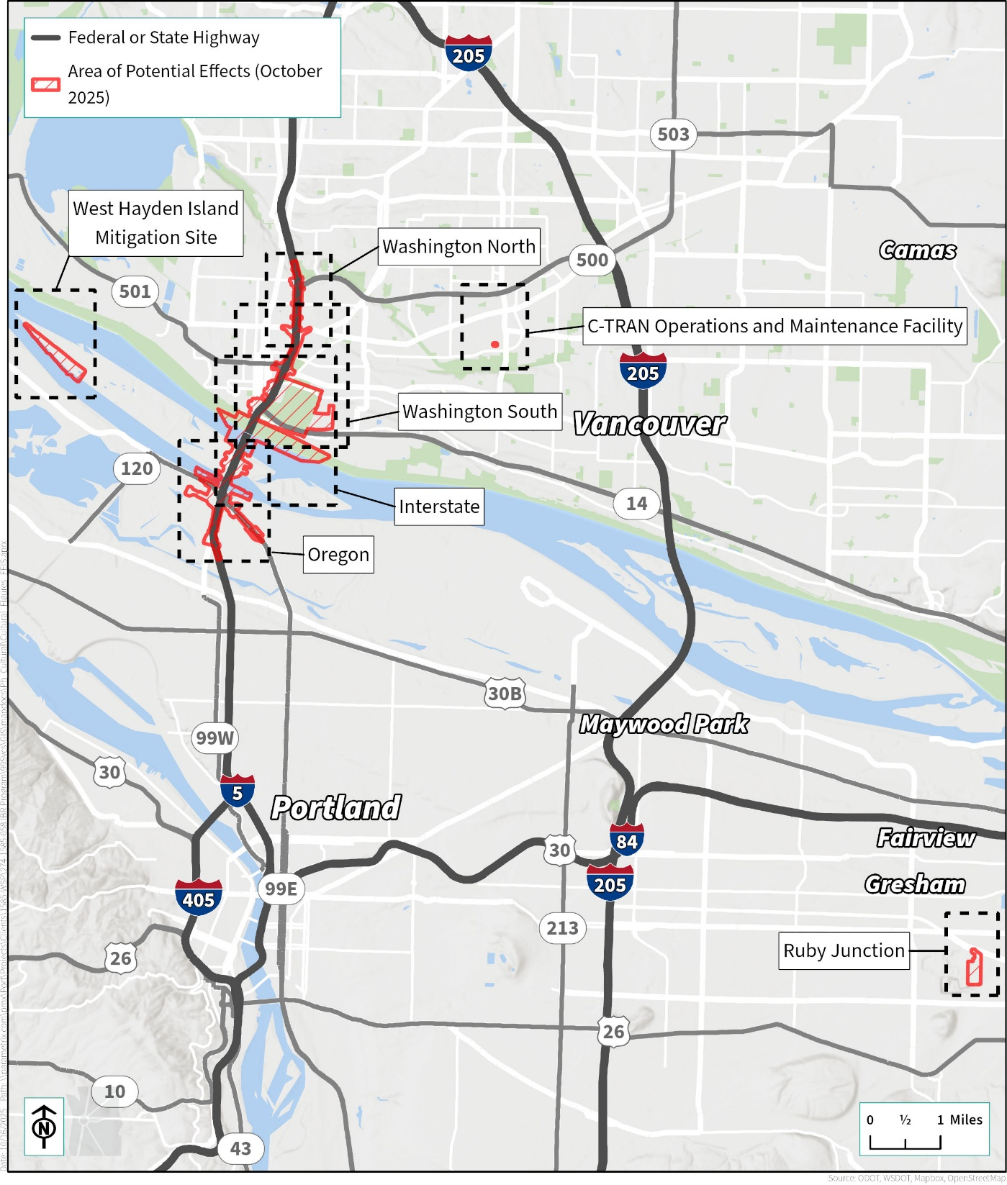

Figure B-2. Area of Potential Effects (October 2025) – Washington North
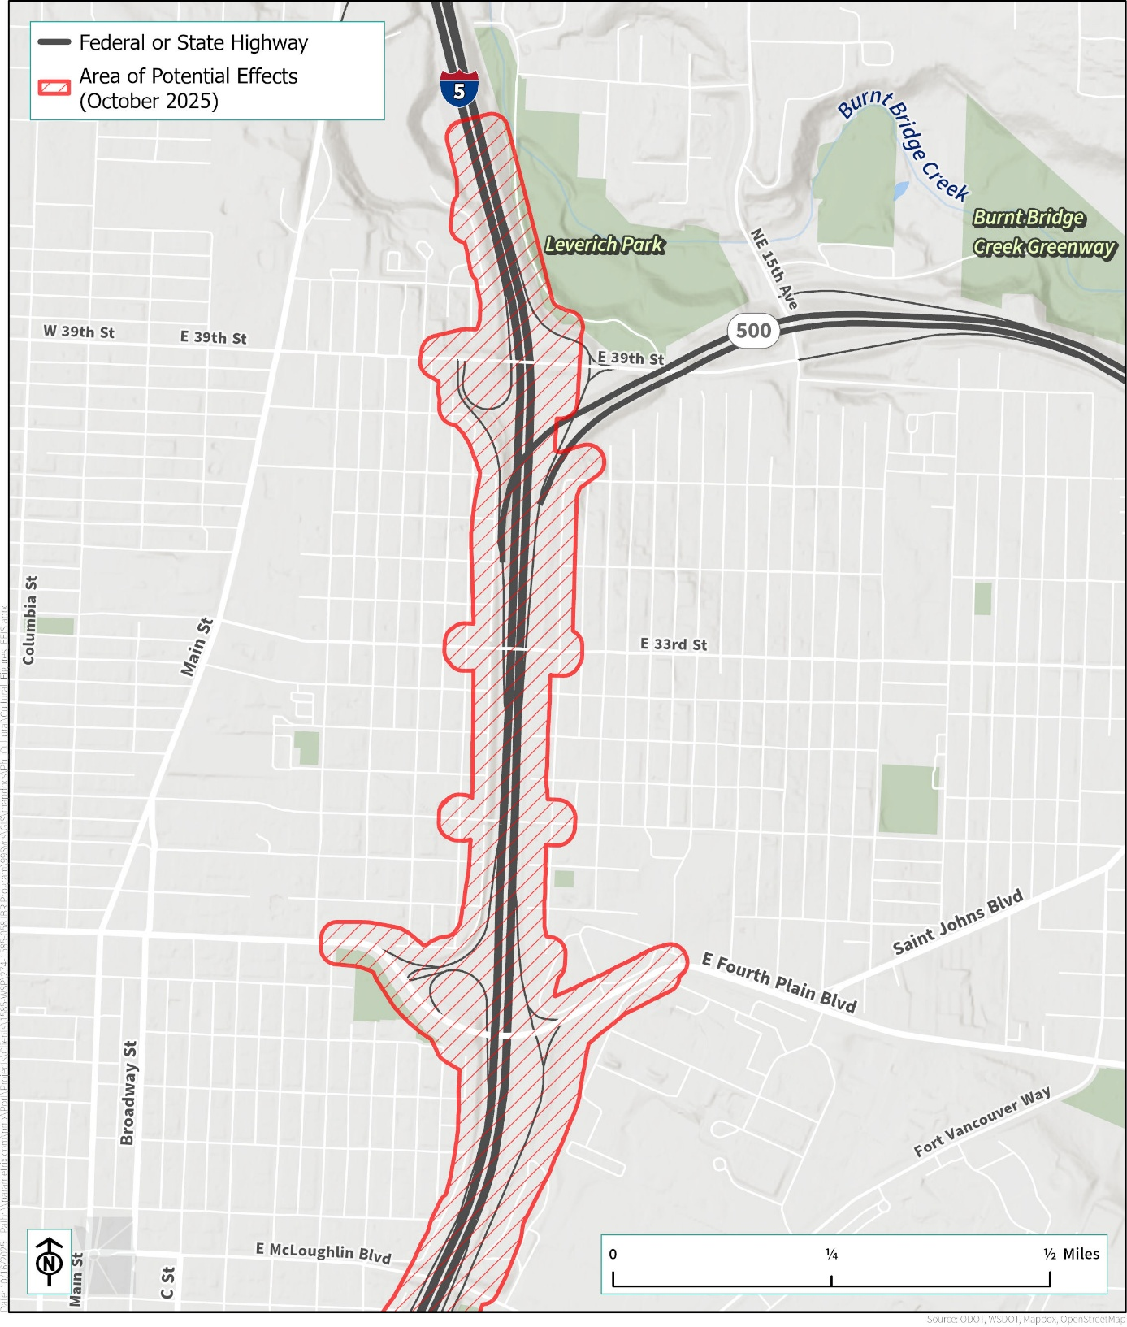

Figure B-3. Area of Potential Effects (October 2025) – Washington South
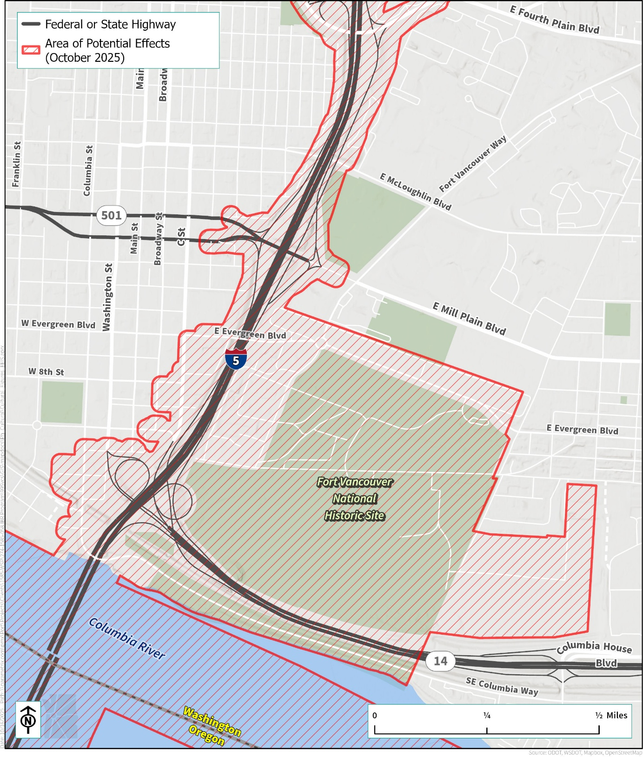

Figure B-4. Area of Potential Effects (October 2025) – Interstate
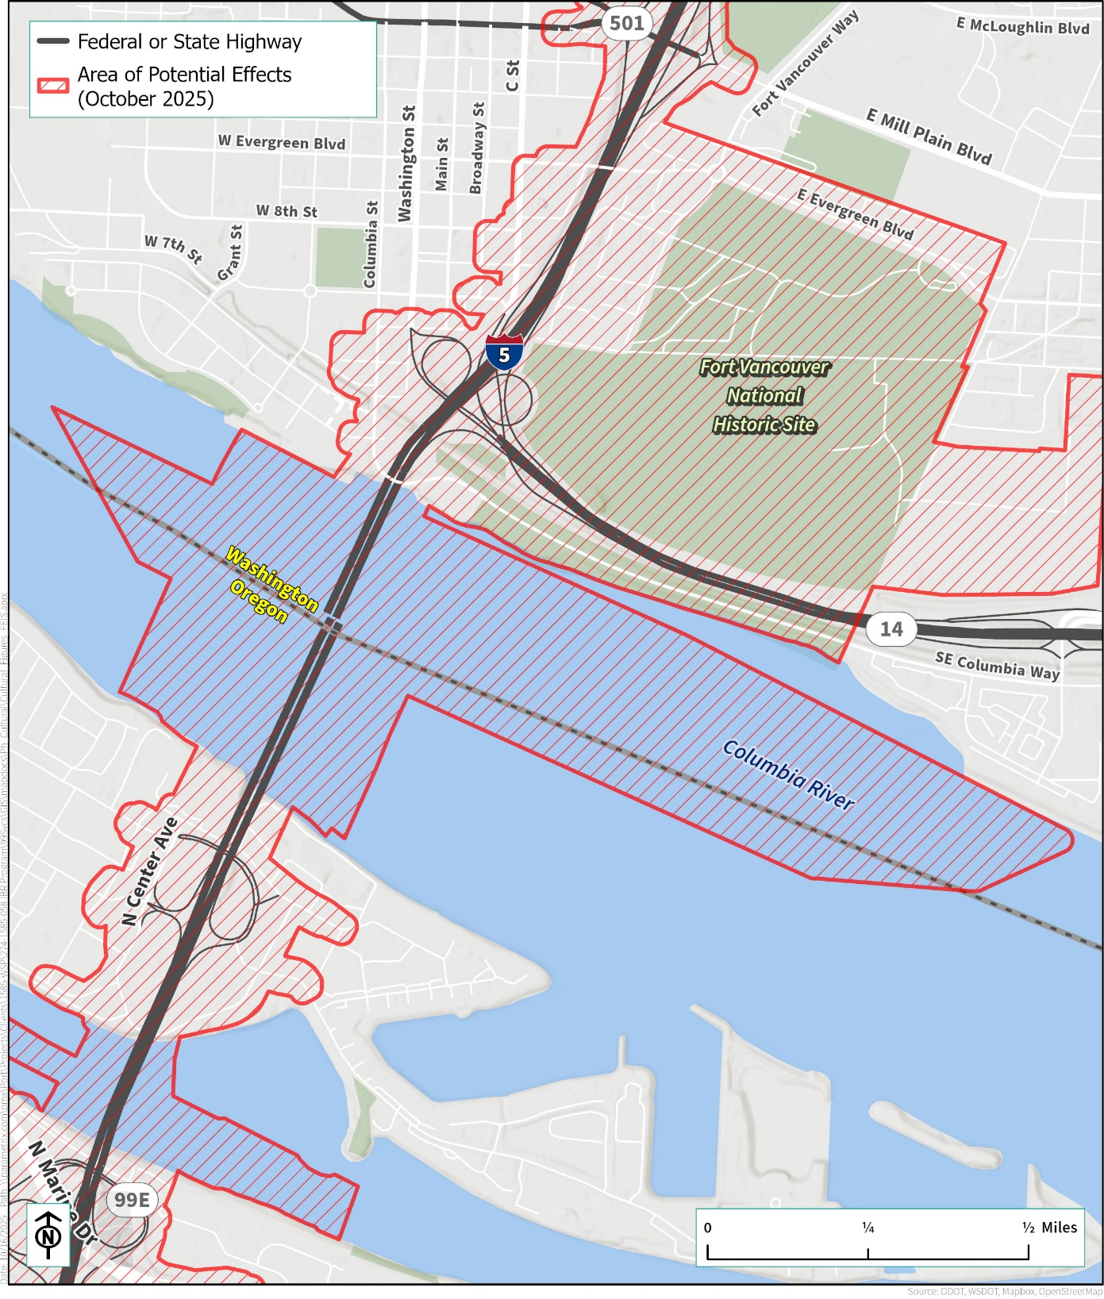

Figure B-5. Area of Potential Effects (October 2025) – Oregon
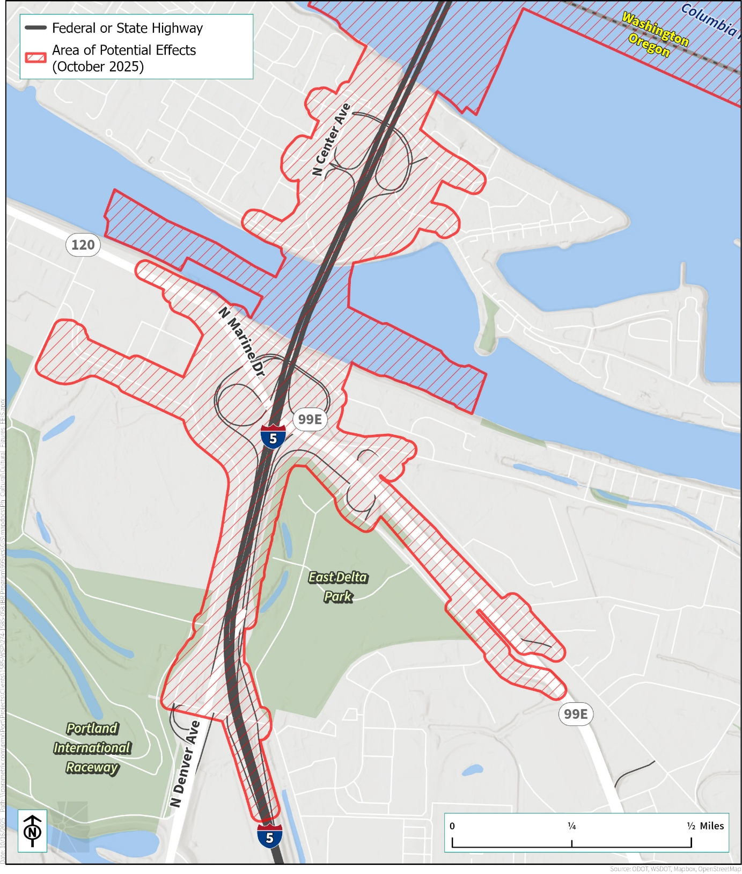

Figure B-6. Area of Potential Effects (October 2025) – C-TRAN Operations and Maintenance Facility, Washington
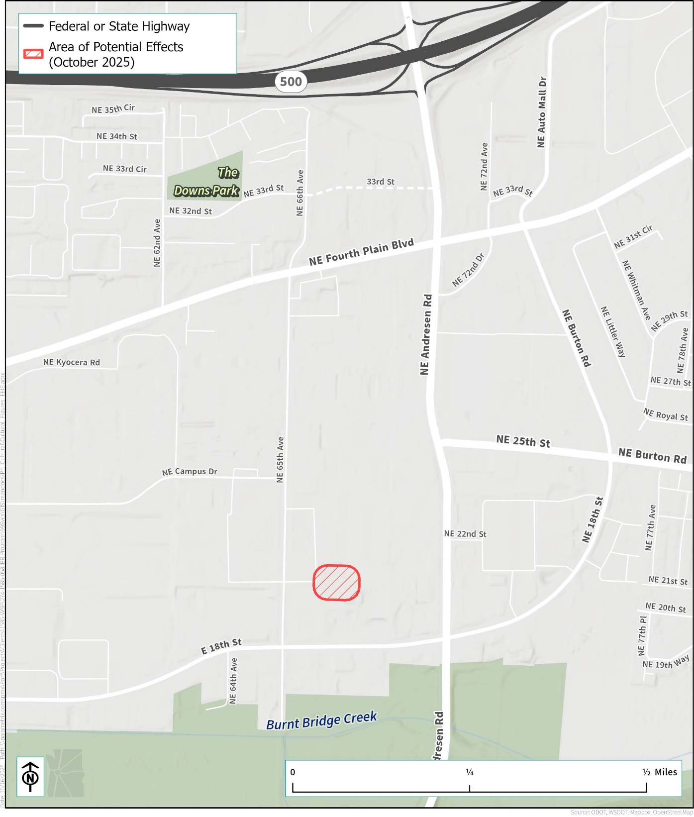

Figure B-7. Area of Potential Effects (October 2025) – Ruby Junction Light-Rail Operations and Maintenance Facility, Oregon
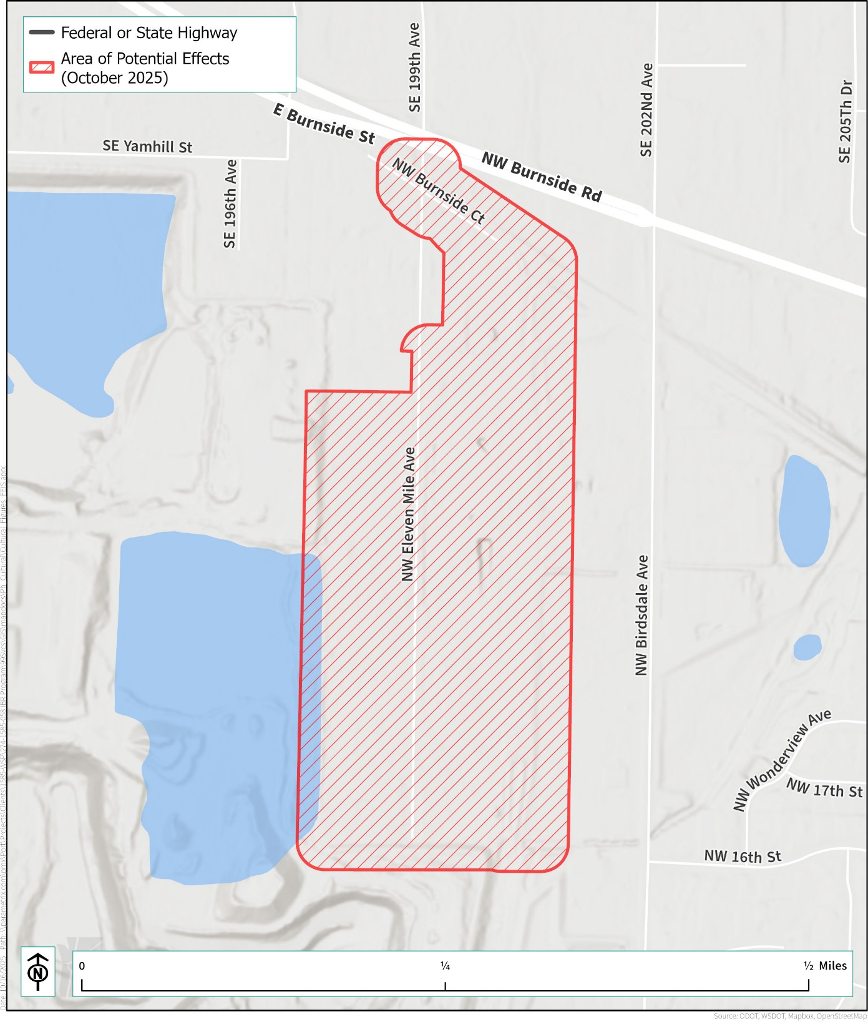

Figure B-8. Area of Potential Effects (October 2025) – West Hayden Island Mitigation Site, Oregon
